**Test condition:**

Acc with 10% of white noise and no spike

Gyro with constant +1 drift

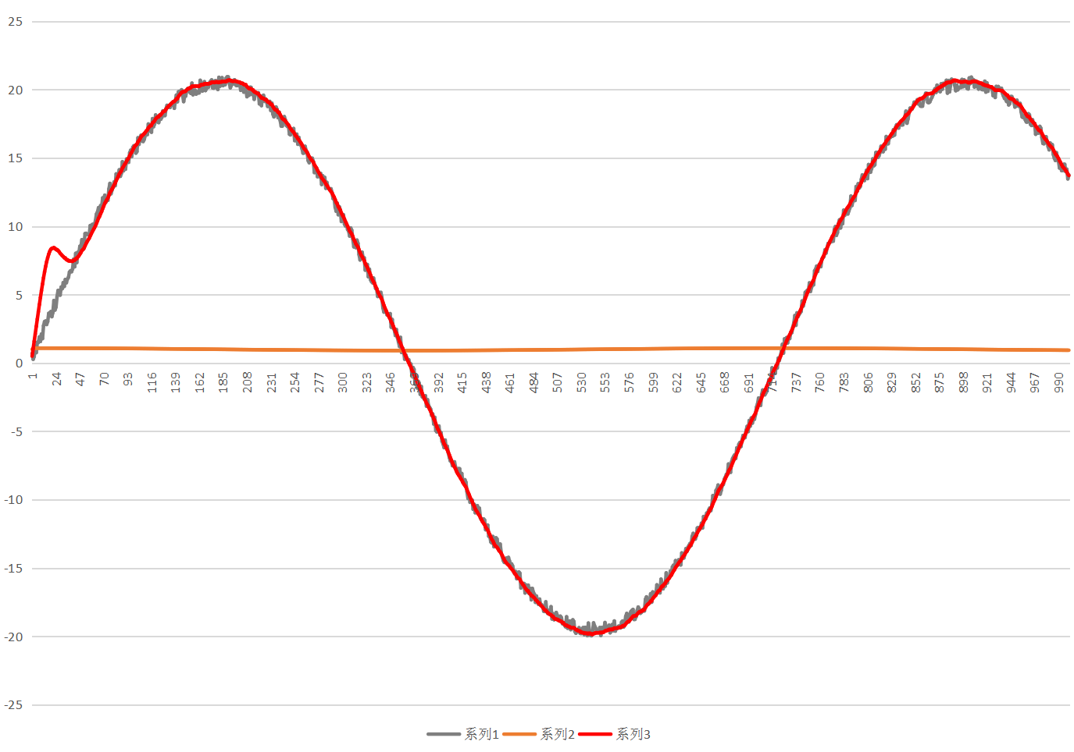

**Test condition:**

Acc with 10% of white noise and 1% of spike,

Gyro with constant +1 drift

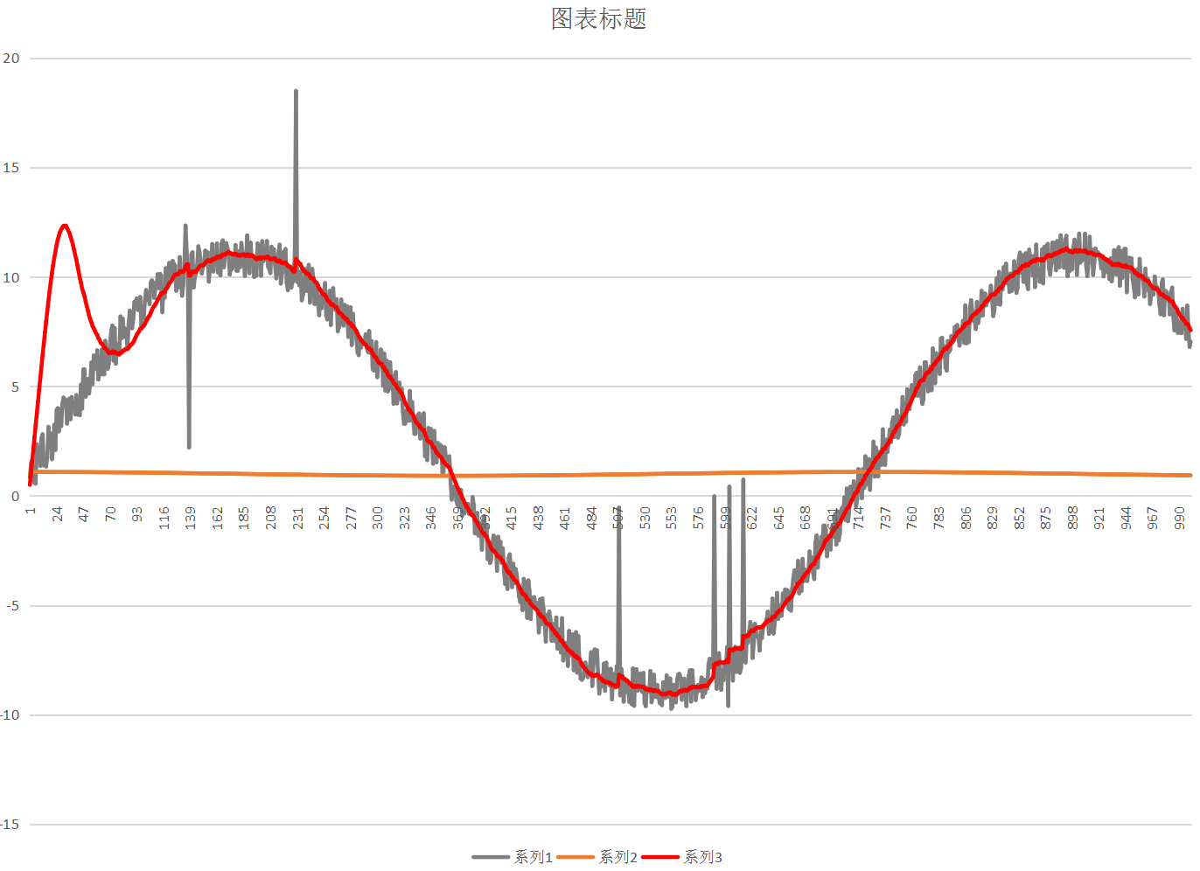

**Test condition:**

Acc with 10% of white noise and 1% of spike,

Gyro with constant +0.05 drift and 10% white noise

